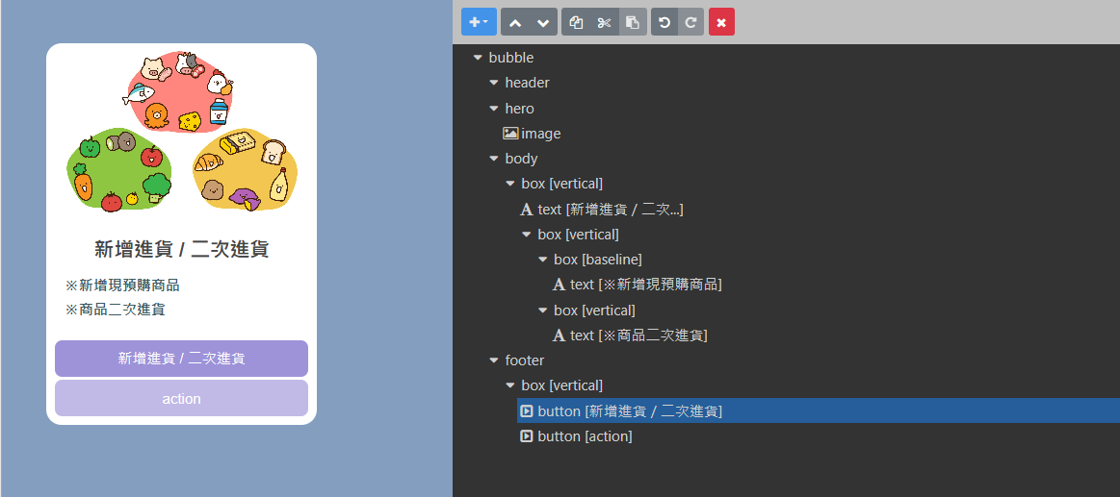

{

"type": "bubble",

"hero": {

"type": "image",

"size": "full",

"aspectRatio": "20:13",

"aspectMode": "fit",

"url": "https://i.imgur.com/vHe8Ee2.jpg"

},

"body": {

"type": "box",

"layout": "vertical",

"contents": [

{

"type": "text",

"text": "新增進貨 / 二次進貨",

"weight": "bold",

"size": "xl",

"align": "center"

},

{

"type": "box",

"layout": "vertical",

"margin": "lg",

"spacing": "sm",

"contents": [

{

"type": "box",

"layout": "baseline",

"spacing": "sm",

"contents": [

{

"type": "text",

"text": "※新增現預購商品",

"color": "#3b5a5f",

"size": "md",

"flex": 5,

"weight": "bold"

}

]

},

{

"type": "box",

"layout": "vertical",

"contents": [

{

"type": "text",

"text": "※商品二次進貨",

"color": "#3b5a5f",

"size": "md",

"flex": 5,

"weight": "bold"

}

]

}

]

}

]

},

"footer": {

"type": "box",

"layout": "vertical",

"spacing": "none",

"contents": [

{

"type": "button",

"style": "primary",

"action": {

"type": "message",

"text": "新增及快速進貨商品",

"label": "新增進貨 / 二次進貨"

},

"height": "sm",

"color": "#9E93D9",

"margin": "sm"

},

{

"type": "button",

"action": {

"type": "uri",

"label": "action",

"uri": "http://linecorp.com/"

},

"style": "primary",

"height": "sm",

"color": "#C1BAE7",

"margin": "sm"

}

],

"flex": 0,

"margin": "none"

}

}